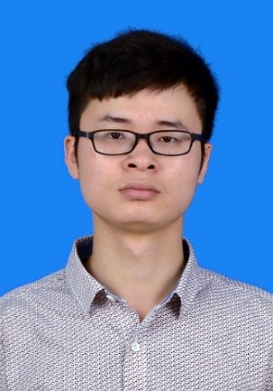

Qingqing Liu（刘青青）

Chaseliu1992@outlook.com Cell :13129932700

Objective : Seeking a position as Clinical SAS Programmer in a highly reputed and professional company.

|  |  |
| --- | --- |
| Summary | * Hands-on experience（3 months） in a pharmaceutical organization as a SAS programmer * Solid understanding of statistical concepts and SAS statistical procedures * Good understanding of clinical data and pharmaceutical development（ICH-GCP,CDISC） * Good command of written and oral English * SAS base and Clinical trials programmer certification |
| Education | **Huazhong University of Science and Technology**–Hubei,Wuhan 2015  Preventive medicine ,Bachelor of medicine  Core Curriculum: Health Statistics , Epidemiology |
| Experience | **Clinical programmer intern**  01/2015 – Present  WuxiPRA clinical research co.ltd – Hubei,Wuhan   * Full-time training about base and advanced SAS programming * Creating tables ,listing and figures for clinical trials report * Mapping raw data to CDISC SDTM standards and deriving analysis datasets according to CDISC ADaM standards   **Graduate Research assistant**  07/2014 – 08/2014  Tongji Medical College  **–** Hubei,Wuhan   * Using SAS/BASE（MEANS,FREQ, UNIVARIATE ,etc.）to clean data and Using EpiData to entry questionnaire ,etc.   **Medical Internship** 09/2013 – 01/2014  Wuhan Union Hospital –Hubei,Wuhan   * Interviewing patients to obtain medical information and measure their vital signs, weight, height,etc. * working with patients in a range of roles, for example, explaining treatment procedures and possible side effects |
| Licenses & Certifications | * SAS Certified Clinical Trials Programmer Using SAS 9 (10/2014) * SAS Certified Base Programmer Using SAS 9 (01/2015) * SAS Certified Advanced Programming Using SAS 9 (03/2015) * CET6(528) (06/2014) |
| Self-judgment | * Exceptional ability to work independently and within a team * Ability to think logically and have good communication skills |